R. Reports Menu: 3. Bianchi Letter

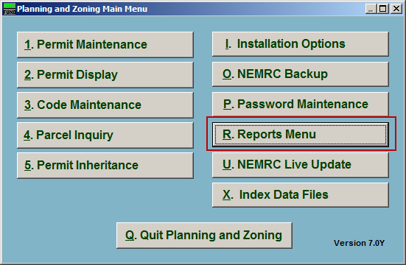
Click on “R. Reports Menu” from the Main Menu and the following window will appear:

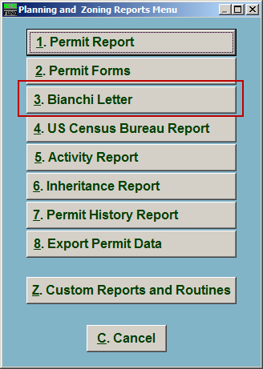
Click on “3. Bianchi Letter” from the Reports Menu and the following window will appear:

Bianchi Letter

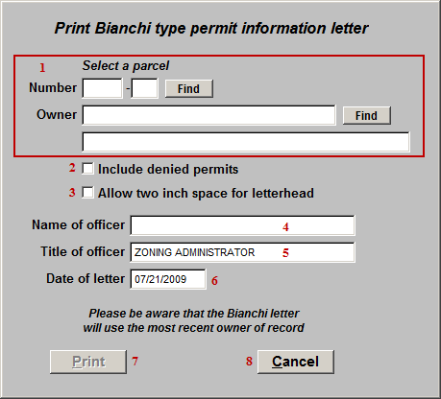
- Select a parcel: Locate the Parcel that the Bianchi Letter is for.

- Include denied permits: Click to check this box to have any Permits that were denied to this Parcel appear on the Bianchi Letter.

- Allow two inch space for letterhead: Click to check this box to have two inches of space at the top of the Bianchi Letter.

- Name of officer: Enter the Name of the office. This will default to the officer from “I. Installation Options.”

- Title of officer: Enter the title of the officer. This will default to the officer title from “I. Installation Options.”

- Date of letter: Enter the date that will appear on the letter.

- Print: Click this button to print. Refer to GENERAL PRINTING for more information.

- Cancel: Click “Cancel” to cancel and return to the Reports Menu.

